M06 Chapter 10 Hands On Projects
- Hands-On Project 10-1
  - Screenshot showing addresses as requested (step 11)
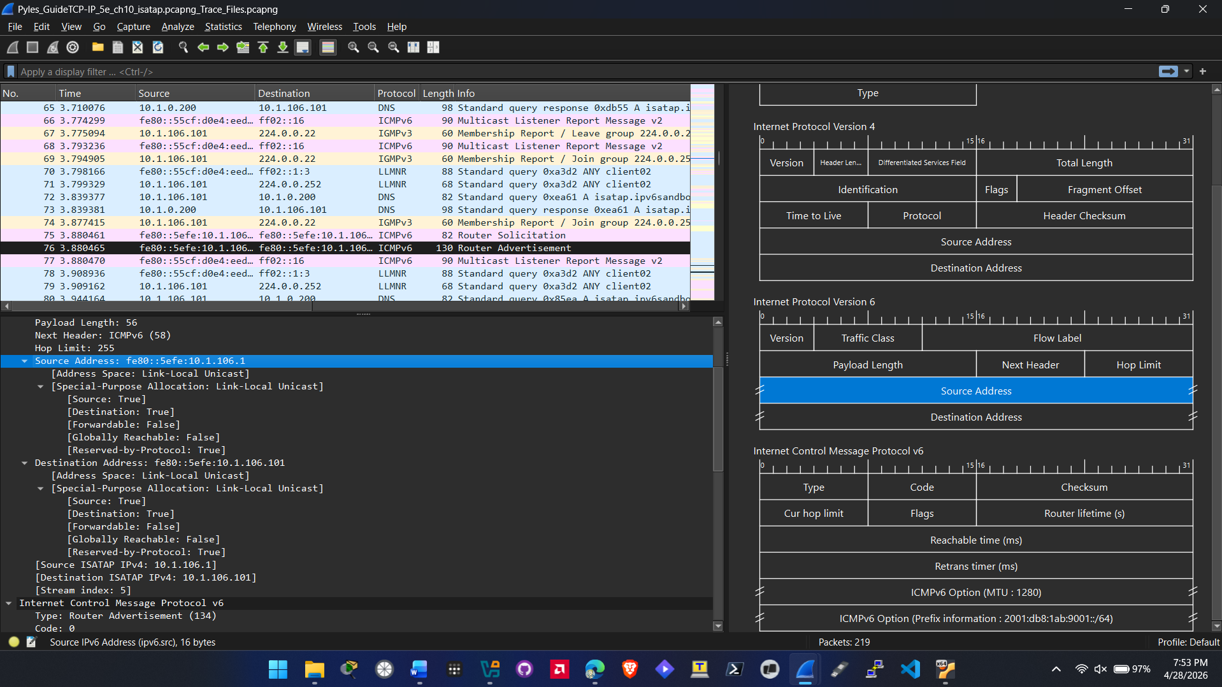
  - Screenshot showing addresses as requested (step 12)
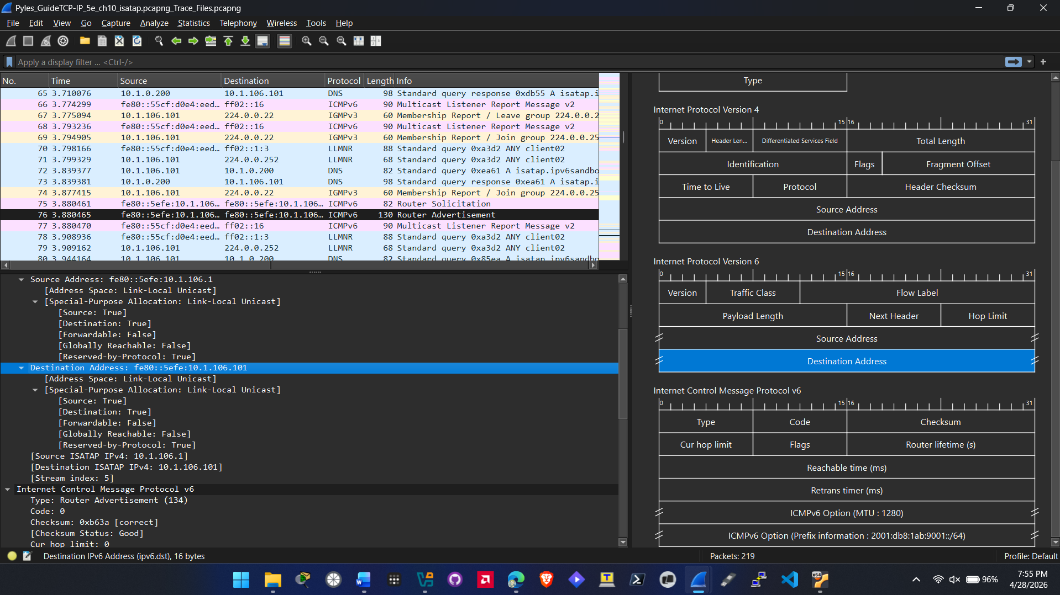
  - Specify Host name, Index Name and number for source and destination (step 13)
Sending Source:
- Host name: Isatap gateway
- Index Name: tunnel adapter no value given by wirehsark.
- Number: 10.1.106.1

Destination Source:
- Host Name: Host/client
- Index Name: tunnel adapter no value given by wireshark.
- Number: 10.1.106.101

  - Screenshot that has been expanded showing prefix field (step 15)
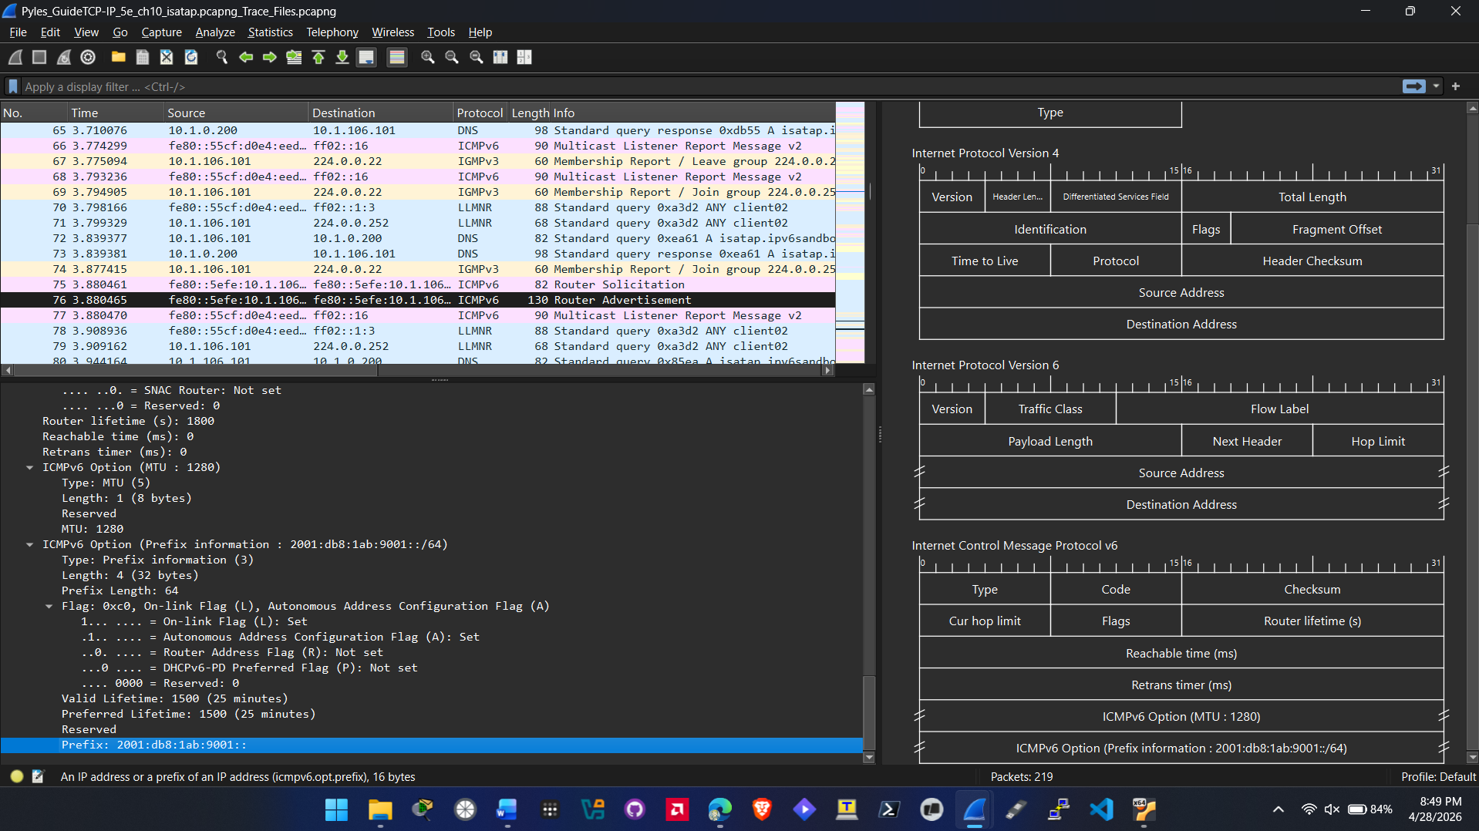
  - Screenshot that has been expanded (step 17)
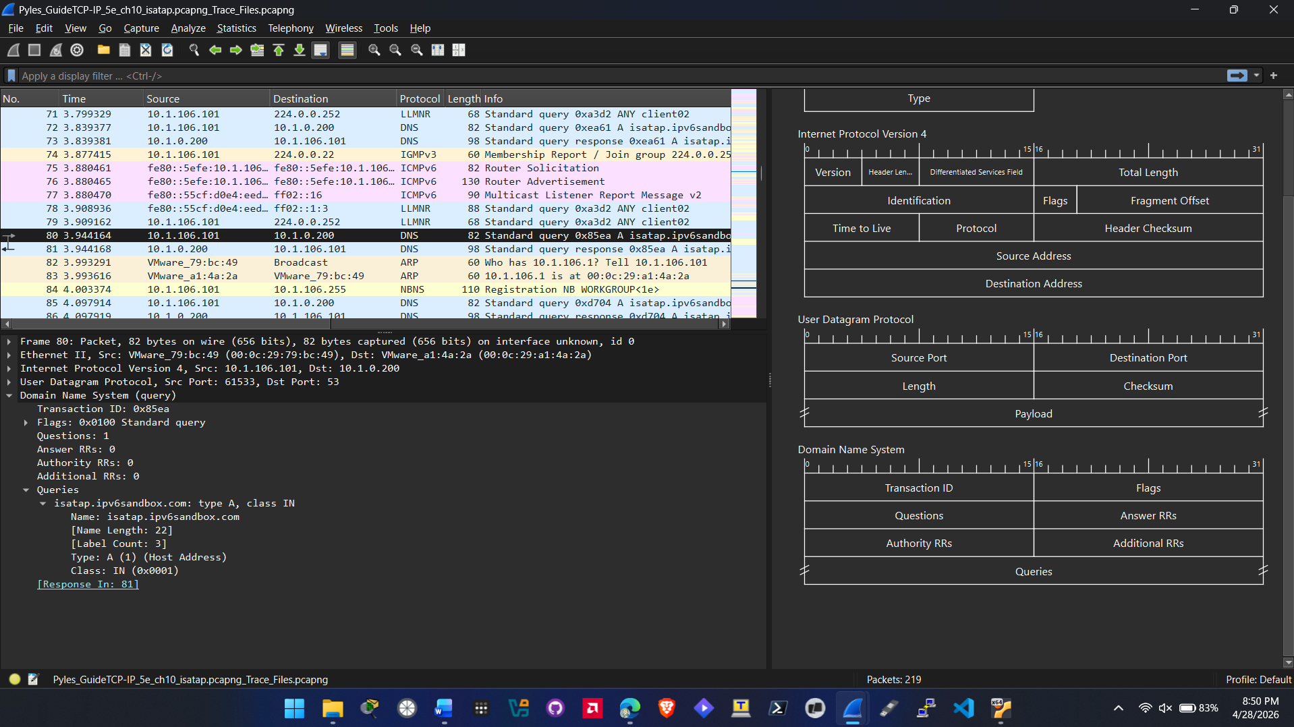
  - Screenshot that has been expanded (step 19)
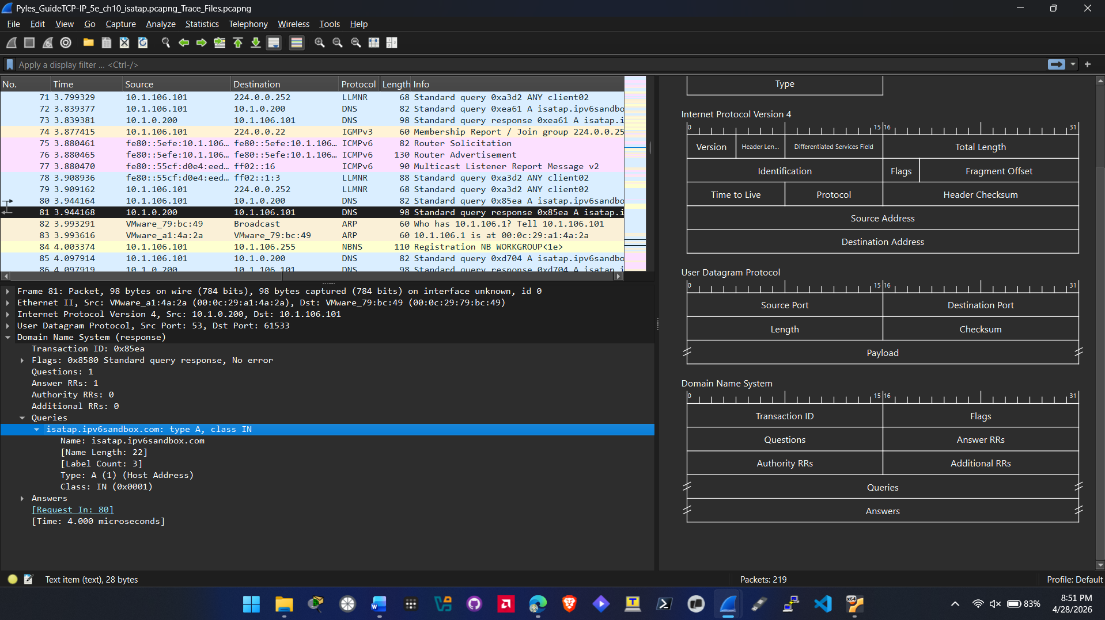

  - Screenshot that has been expanded (step 21)
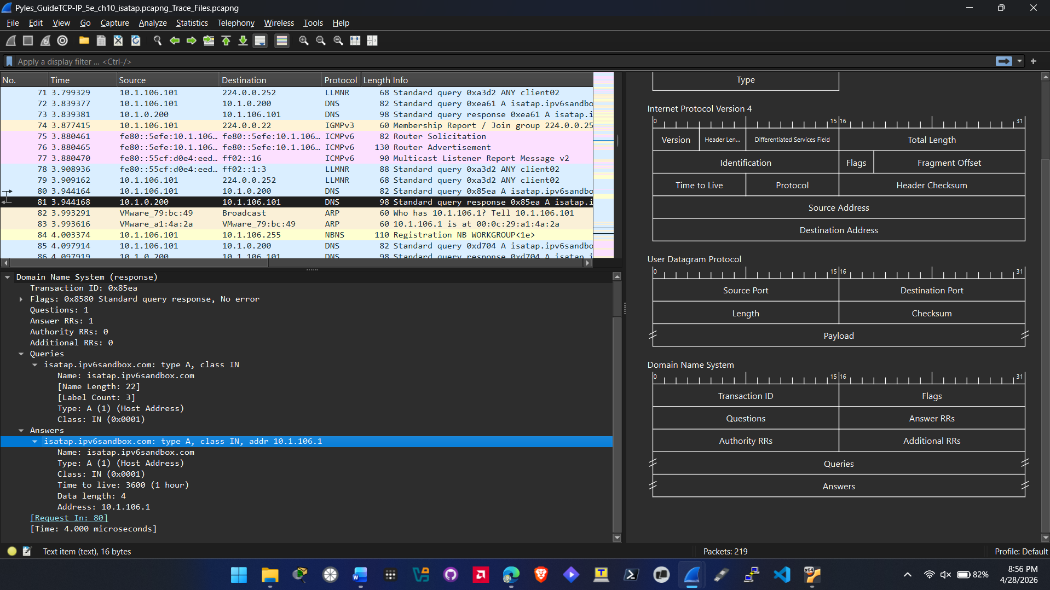
- Hands-On Project 10-2
  - Screenshot showing addresses as requested (step 6)
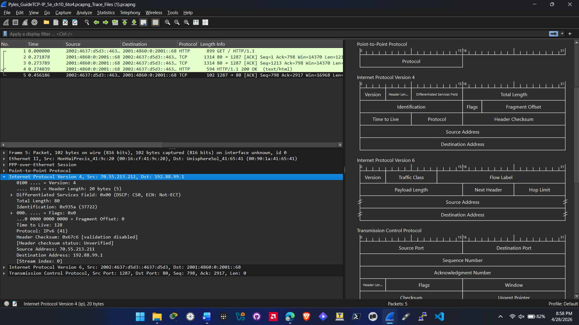

  - Screenshot showing address as requested (step 8)
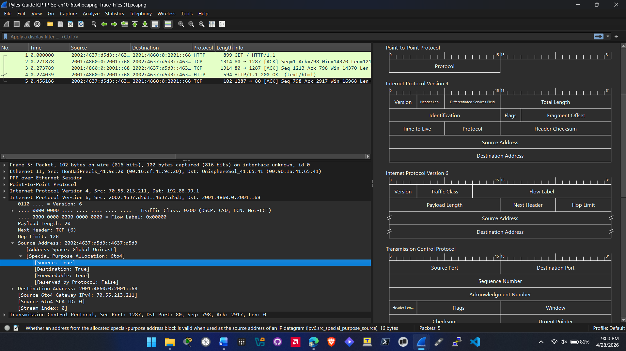
  - Screenshot showing address as requested (step 9)
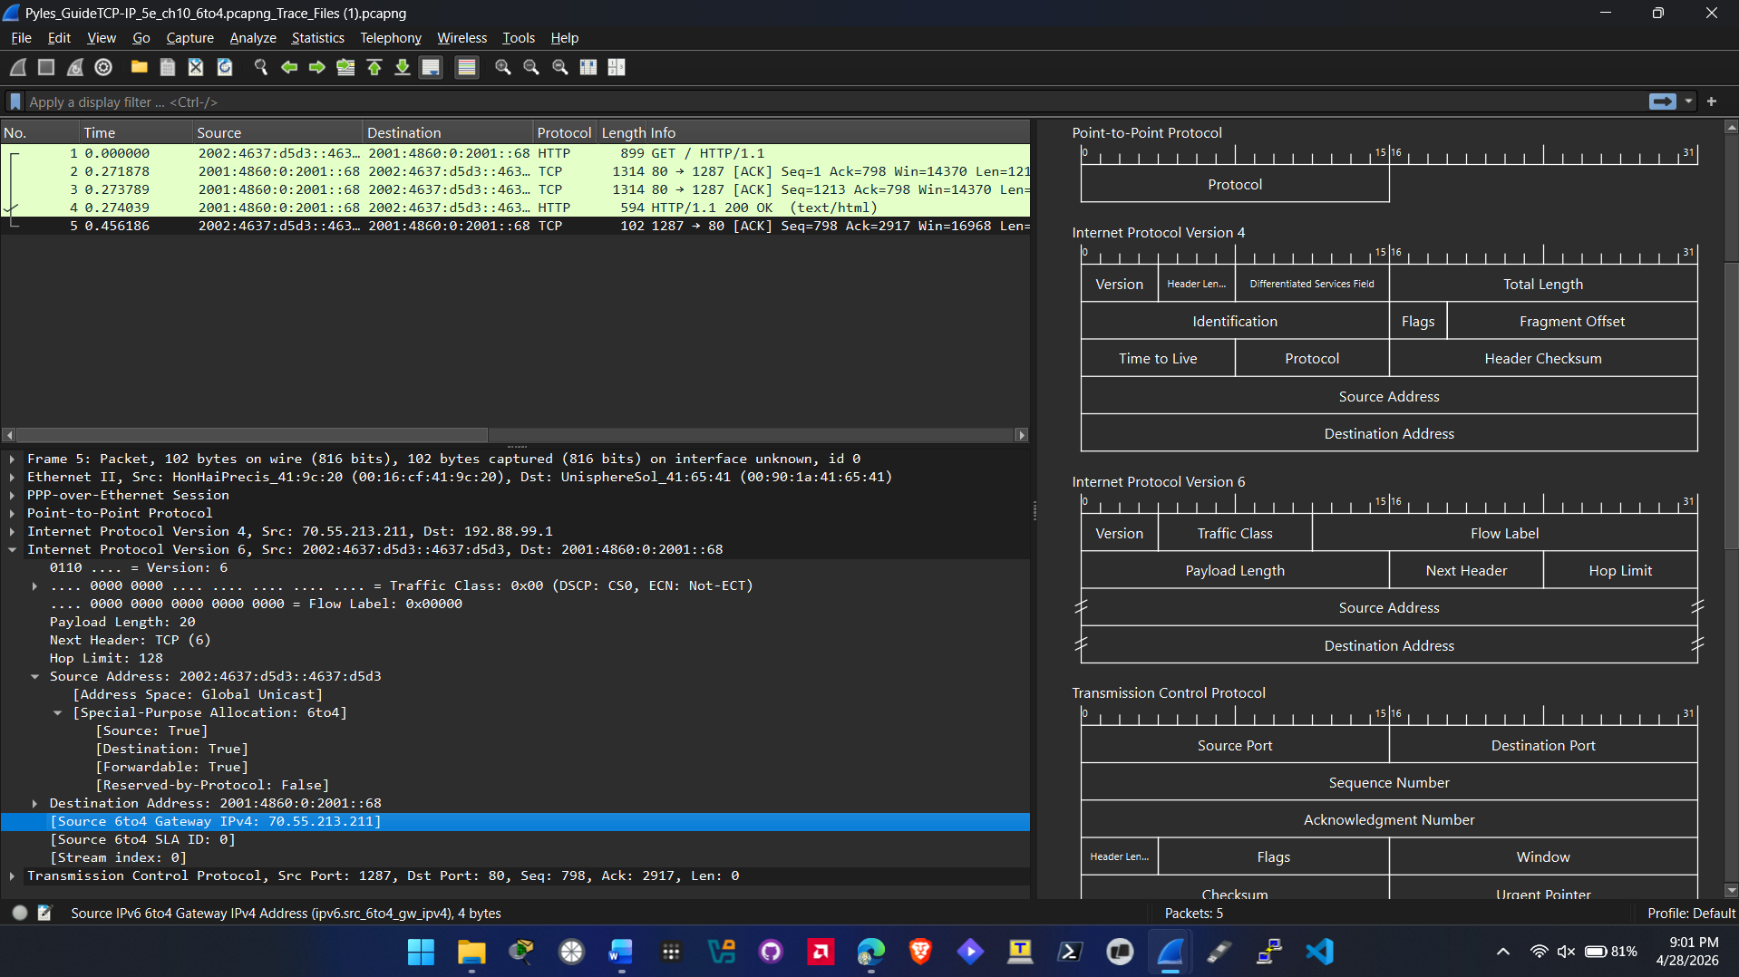

  - Screenshot showing address as requested (step 10)
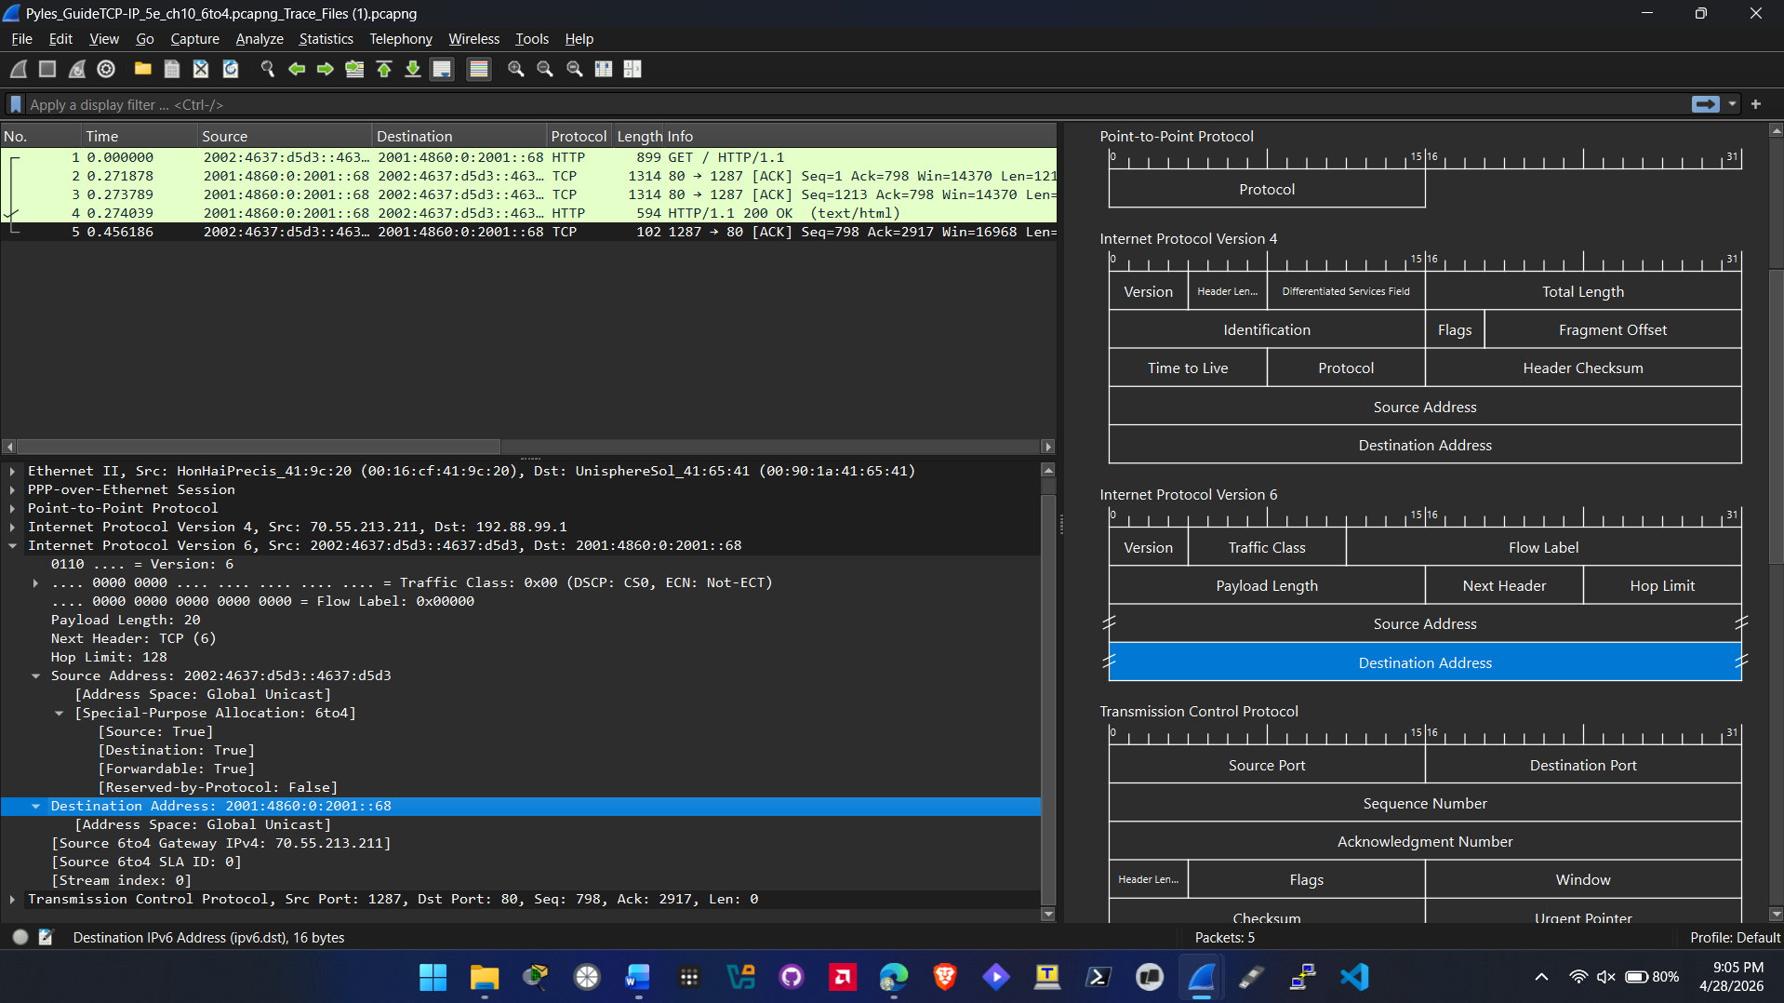
  - Screenshot showing acknowledgement as requested (step 12)
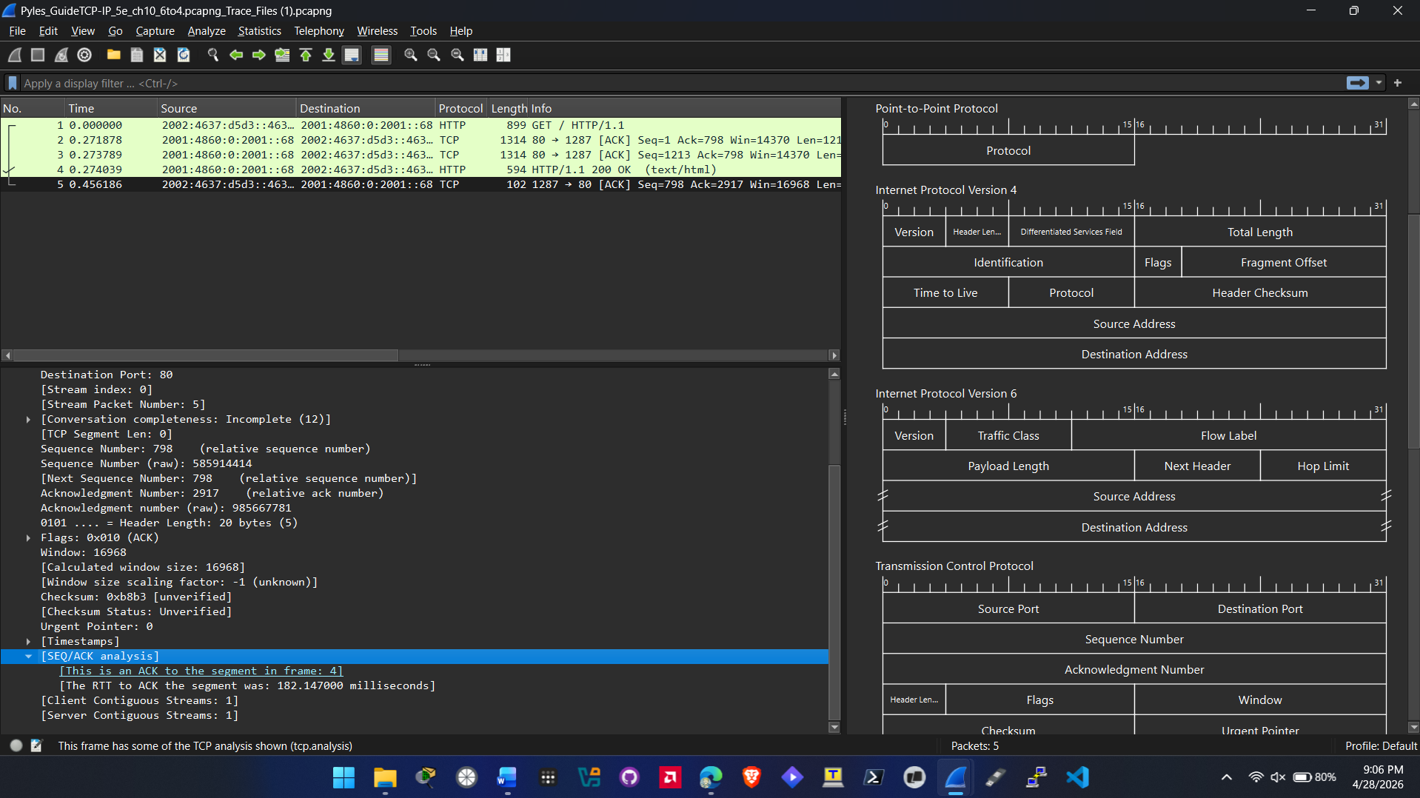

- Hands-On Project 10-3
  - Screenshot showing addresses as requested (step 7)
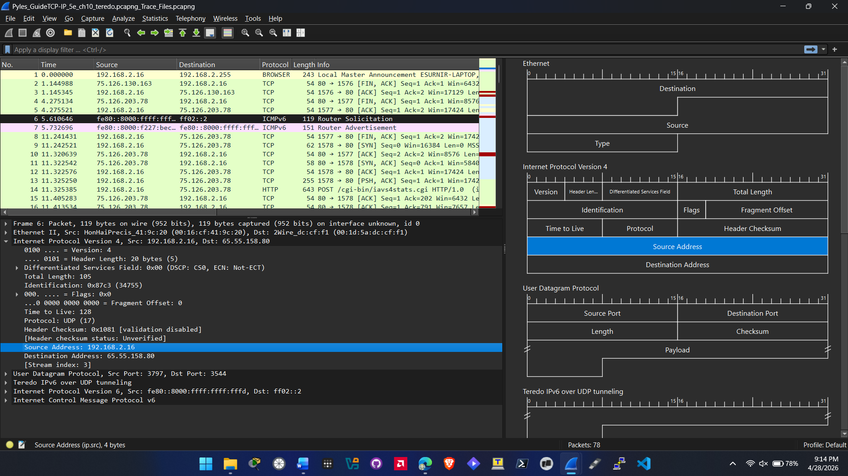
  - Screenshot showing ports as requested (step 9)
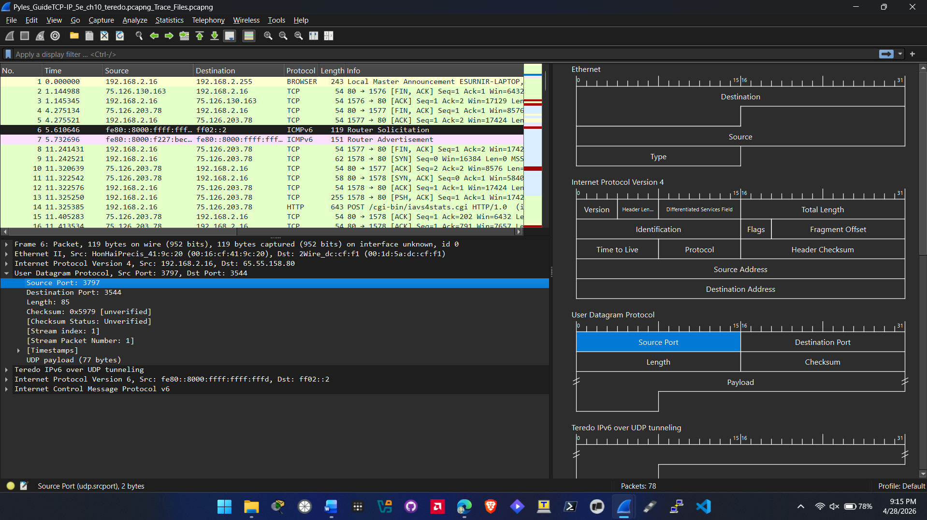

  - Screenshot showing ports as requested (step 10)
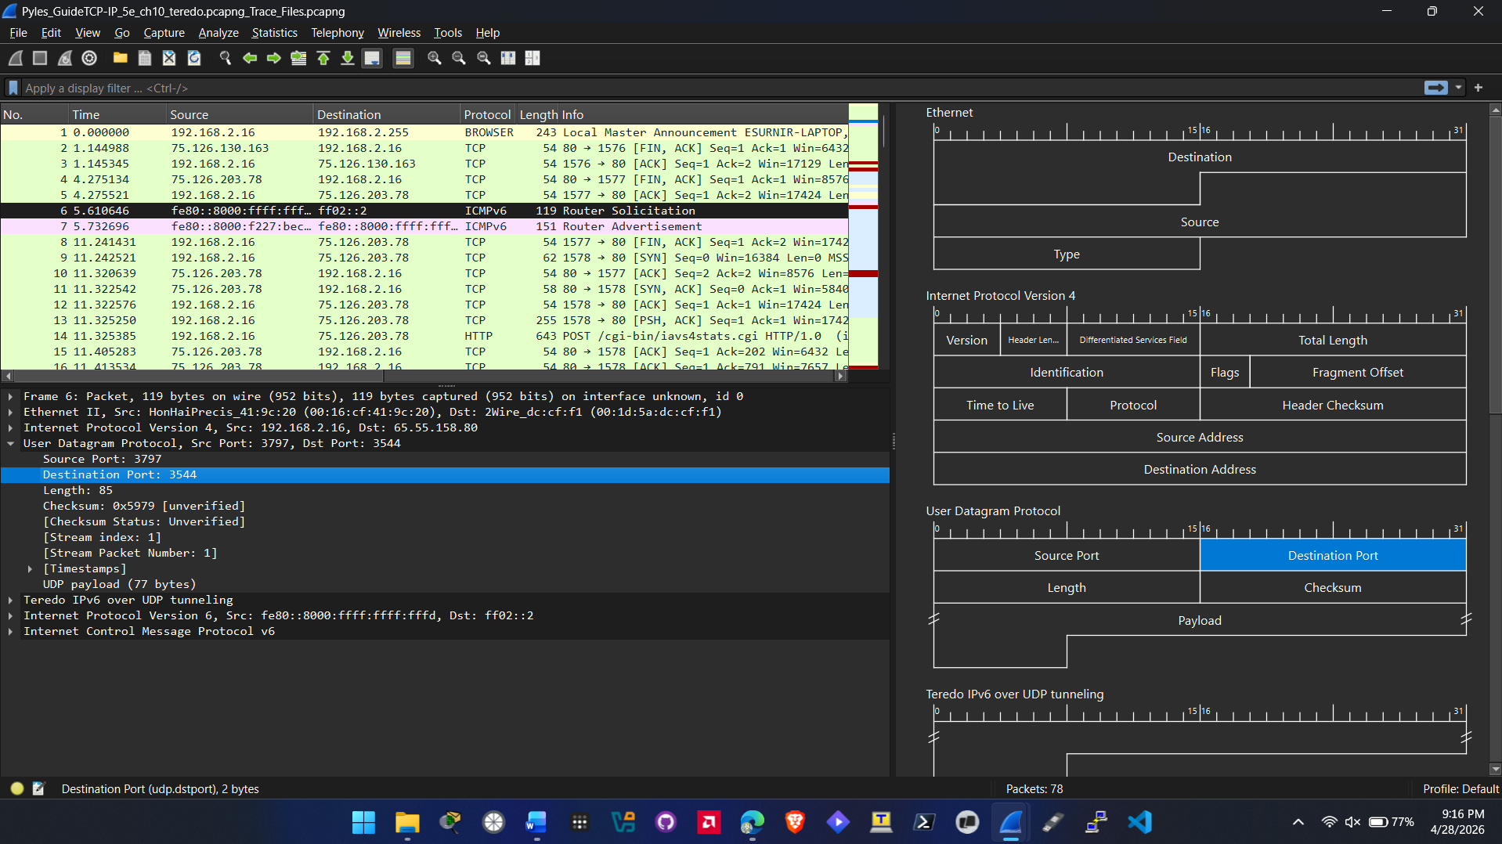
  - Screenshot showing header information as requested (step 12)
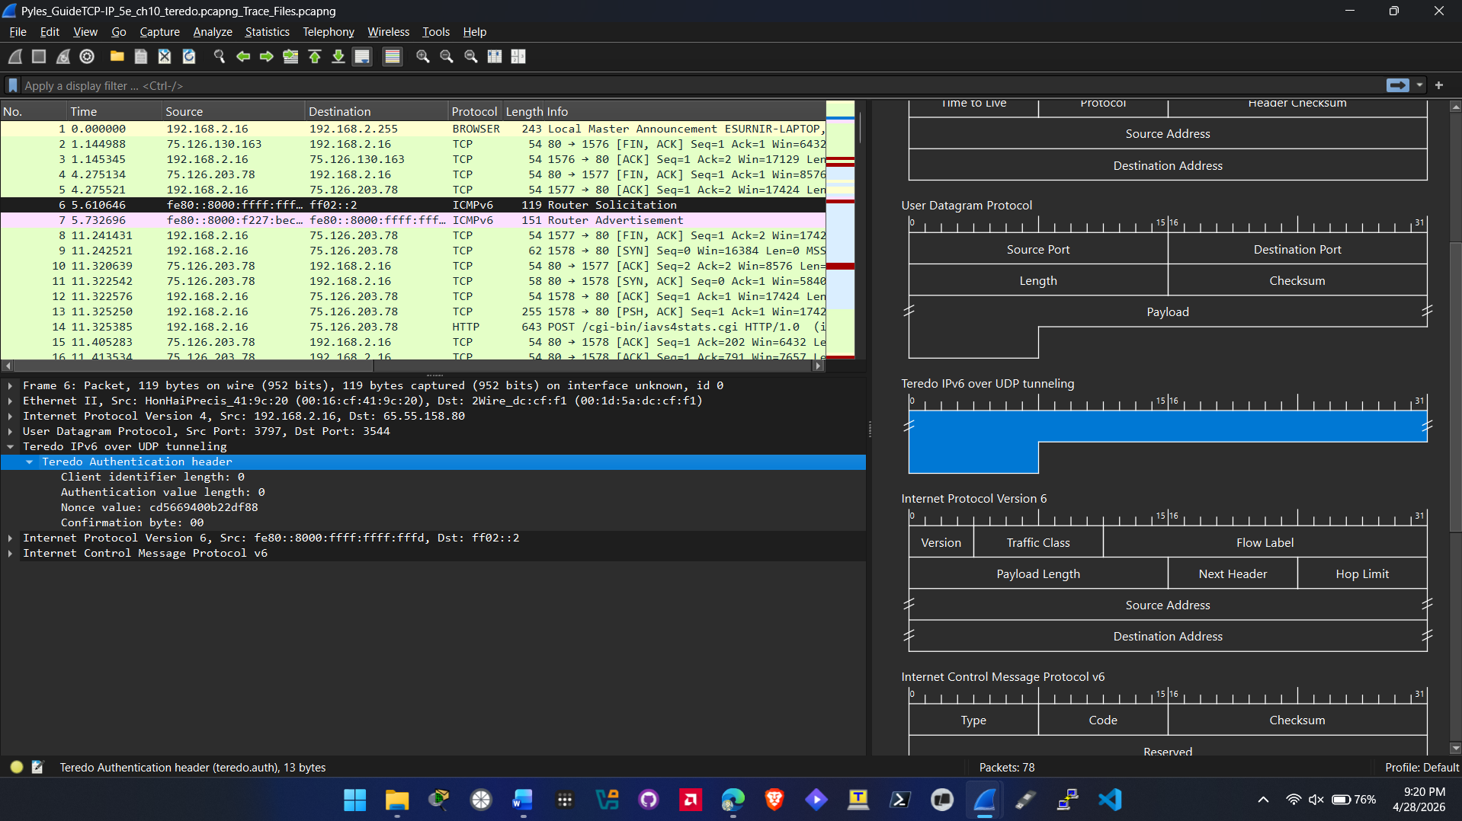

  - Screenshot showing source and destination fields as requested (steps 15 & 16)
Source:
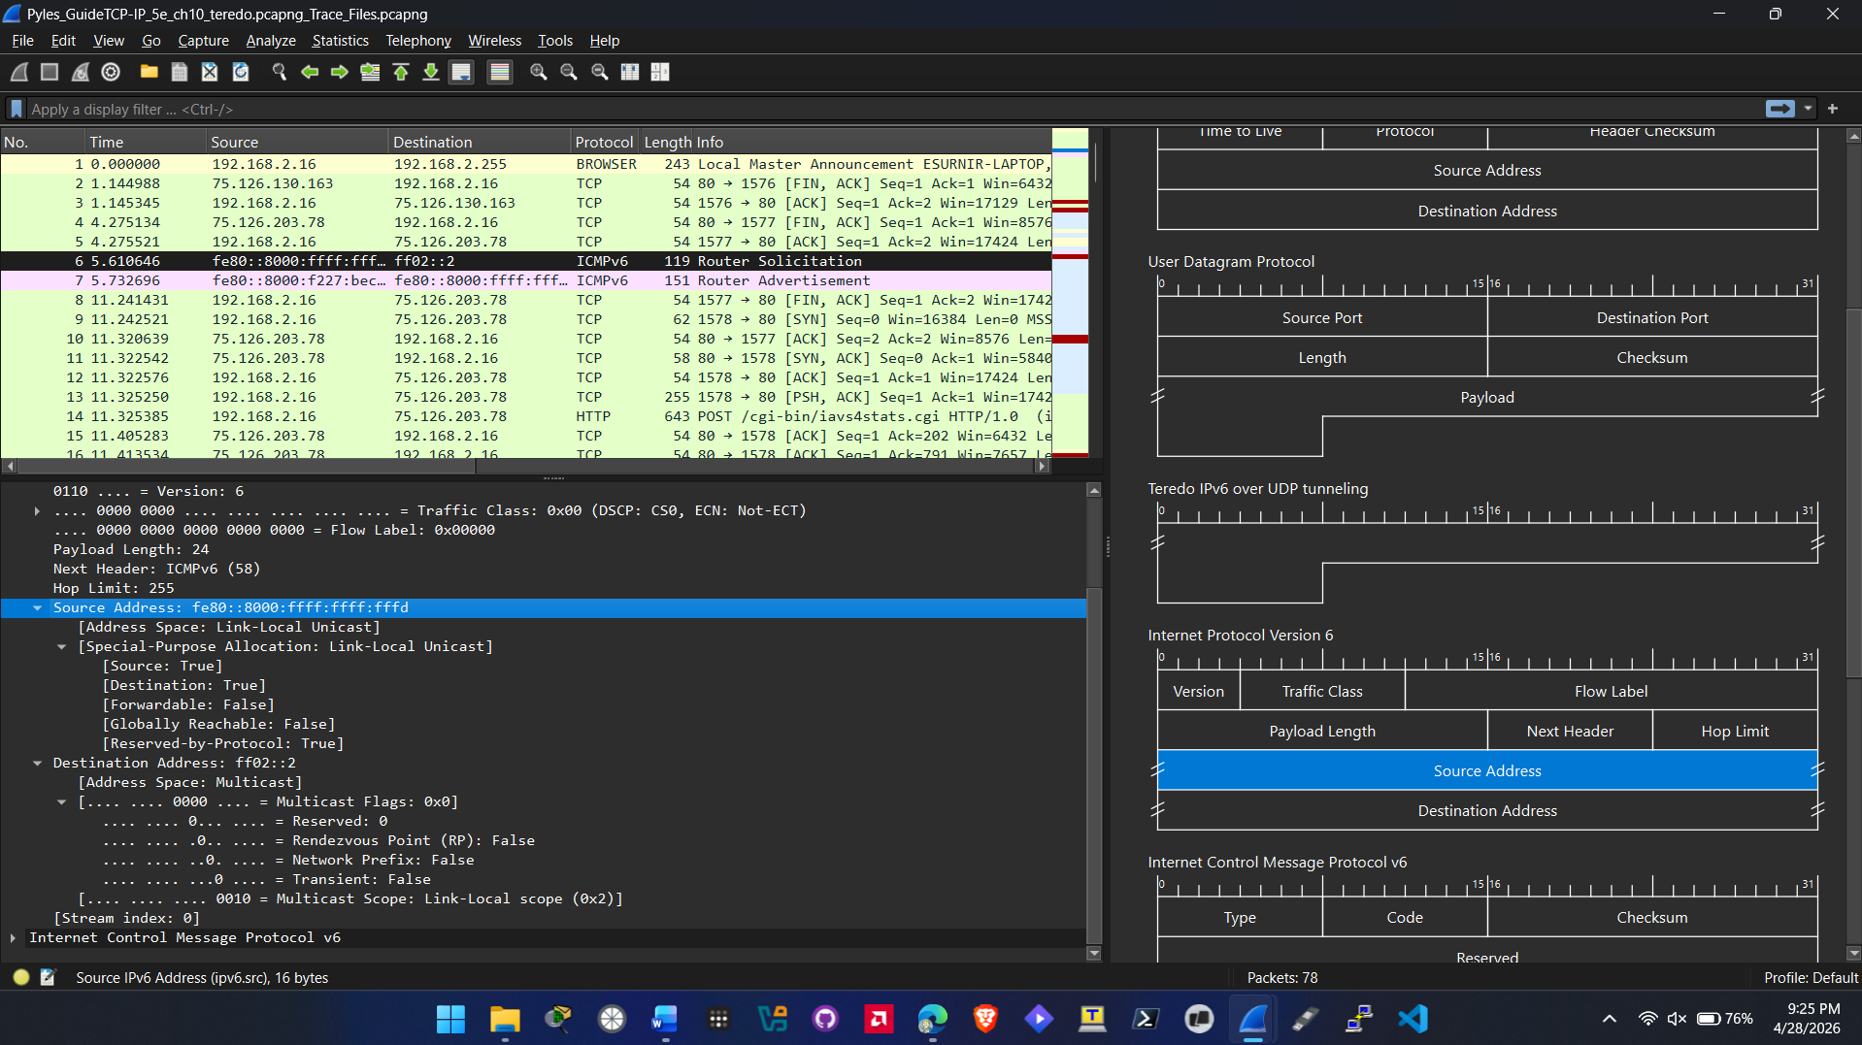
Destination:
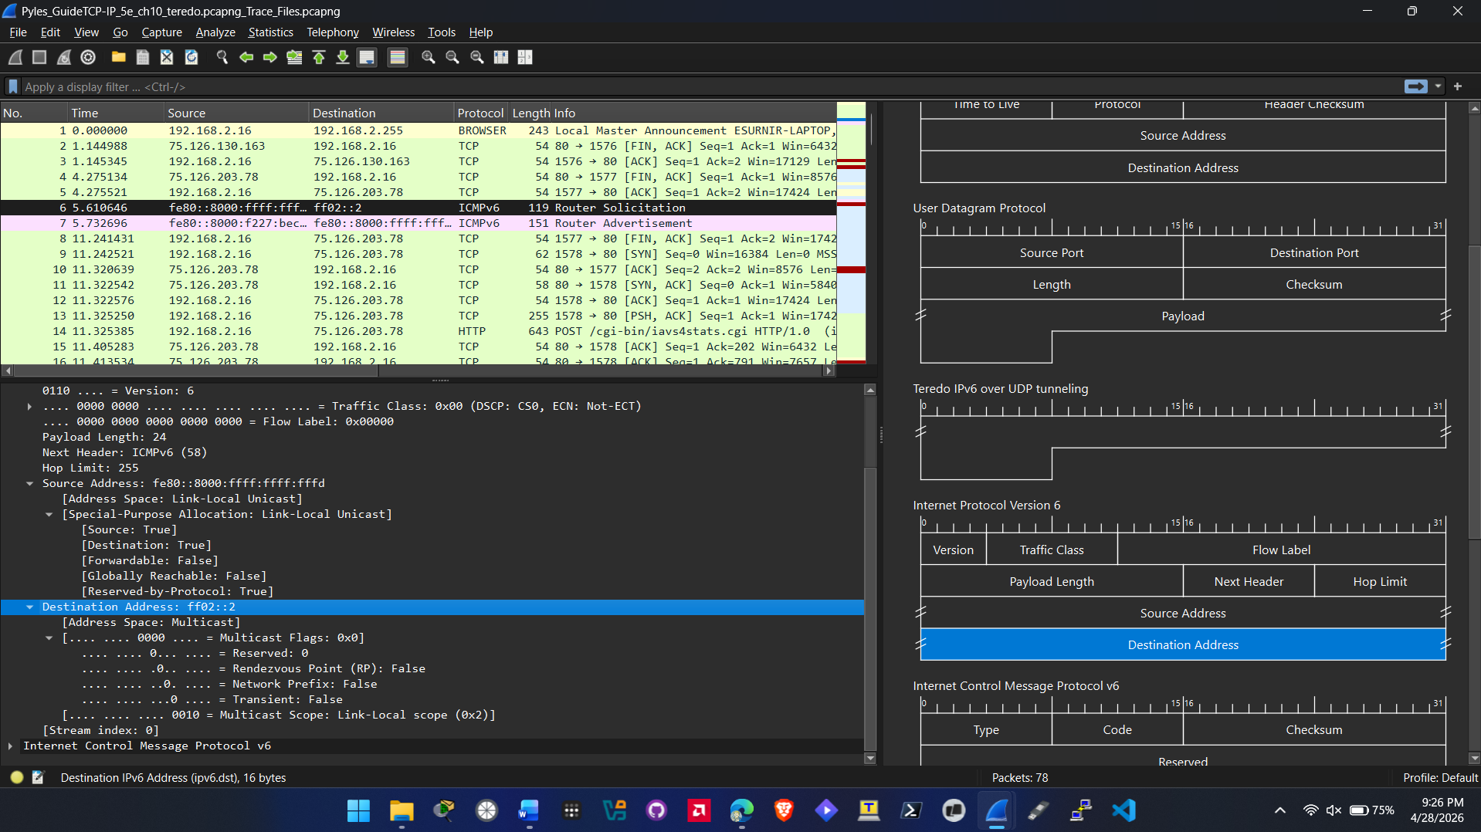
  - Screenshot showing information as requested (step 18)
